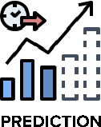

ProjectDesignPhase-

IITechnologyStack(Architecture&Stack)

|  |  |
| --- | --- |
| *Date* | *17October2022* |
| *TeamID* | *PNT2022TMID39349* |
| *ProjectName* | ***NATURALDISASTERSINTENSITYANALYSISANDCLASSIFICATIONUSINGARTIFICIALINTELLIGENCE*** |

TechnicalArchitecture:

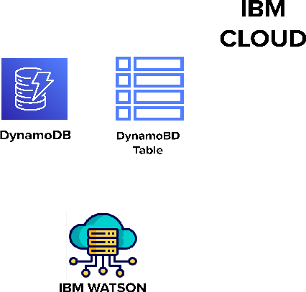

Table-1:Components&Technologies:

|  |  |  |  |
| --- | --- | --- | --- |
| ***S.No*** | ***Component*** | ***Description*** | ***Technology*** |
| *1.* | *UserInterface* | *Userinteractswithapplicationforthepredictionof*  *AnyNaturaldisasterwhichwillhappeninfutureminutes.* | *HTML,CSS,JavaScript,Django,Python.* |
| *2.* | *FeatureEngineeringPipeline* | *Algorithmscan' t makesenseof rawdata. Wehavetoselect, transform, combine, and otherwiseprepareourdatasothealgorithmcanfindusefulpatterns.* | *Imageprocessing,patternextraction,etc.* |
| *3.* | *ModelTrainingkit* | *Itlearnspatternsfromthedata.Thentheyuse*  *thesepatternstoperformparticulartasks.* | *MulticlassClassification*  *Model,RegressionModel,etc.* |
| *4.* | *Predictionunit* | *Thisfunctionisusedtopredictoutcomesfromthenewtraineddatatoperformnewtasksandsolvenew*  *problems.* | *Decisiontrees,Regression,Neuralnetworks.* |
| *5.* | *Evaluationsystem* | *ItmonitorsthathowAlgorithmperformsondata*  *aswellasduringtraining.* | *Chi-Square,ConfusionMatrix,etc.* |
| *6.* | *Interactiveservices* | *Tointeractwithourmodelandgiveitproblemsto*  *solve.UsuallythistakestheformofanAPI,auserinterface,oracommand-lineinterface.* | *Applicationprogramminginterface,etc.* |
| *7.* | *Datacollectionunit* | *Dataisonlyusefulif it’ saccessible,soit needstobestoredideallyinaconsistentstructureandconvenientlyin*  *oneplace.* | *IBMCloud,SQLServer.* |
| *8.* | *Datagenerationsystem* | *Everymachinelearningapplicationlivesoff*  *data.Thatdatahastocomefromsomewhere.Usually,*  *it’sgeneratedbyoneofyourcorebusinessfunctions.* | *Syntheticdatageneration.* |
| *9.* | *Databasemanagementsystem* | *Anorganizedcollectionofdatastoredindatabase,sothatitcanbeeasilyaccessed*  *andmanaged.* | *MySQL,DynamoDBetc.* |
| *10.* | *IBMCloudservices* | *Processeddatastoredincloudservicewhich* | *IBMCloudetc.* |

|  |  |  |  |
| --- | --- | --- | --- |
|  |  | *canbeaccessbytheadminanywhereovertheinternet.* |  |

Table-2:ApplicationCharacteristics:

|  |  |  |  |
| --- | --- | --- | --- |
| ***S.No*** | ***Characteristics*** | ***Description*** | ***Technology*** |
| *1.* | *Open-SourceFrameworks* | *An open sourceframework isa templateforsoftwaredevelopmentthatisdesignedbyasocialnetworkofsoftwaredevelopers.Theseframeworksarefreeforpublicuseandprovidethefoundationforbuildingasoftware*  *application.* | *Keras,pensorflow.* |
| *2.* | *Authentication* | *Thiskeepsourmodelssecureandmakessureonly*  *thosewhohavepermissioncanusethem.* | *EncryptionandDecryption(OTP).* |
| *3.* | *Applicationinterface* | *Userusesmobileapplicationandwebapplicationtointeractwithmodel* | *AndroidandWeb*  *Development( PhoneGap,ReactNative,andNativeScript).* |
| *4.* | *Availability(bothOnlineandOfflinework)* | *I tsincludeboth onlineand offlinework. Asgoodinternetconnectionisneedforonlineworktoexplorethesoftwareperfectly.Offline*  *workincludesthesaveddatatoexploreforlatertime.* | *Caching,backendserver.* |
| *5.* | *RegularUpdates* | *Thetrulyexcellentsoftwareproductneedsacontinuousprocessof improvementsand updates.Maintain yourserver and makesurethat yourcontent isalwaysup-to-date.Regularlyupdateanappandenrichitwithnew*  *features.* | * *WaterfallApproach* * *IncrementalApproach* * *SpiralApproach* |
| *6.* | *Personalization* | *Softwarehasfeatureslikeflexiblefonts,backgrounds,settings,colourthemes,etc.whichmakeasoftwareinterfacelooksgoodandfunctional.* | * *HubSpot* * *Proof* |